**Question 1 :**

//Create a class called Student with the following attributes:

Roll Number,Name,Department

Write a method to display student details. Create and display the details of three students using objects

class Student {

//Attributes

int rollNumber;

String name;

String department;

//Method to display details

void displayDetails(){

System.out.println("Roll Number : "+rollNumber);

System.out.println("Name : "+name);

System.out.println("Department : "+department);

System.out.println("--------------------------");

}

public static void main(String args[]){

// Create object for student 1

Student s1 = new Student();

s1.rollNumber = 1;

s1.name = "Sowbarnika";

s1.department = "IT";

//Create object for student 2

Student s2 = new Student();

s2.rollNumber = 2;

s2.name = "Divya";

s2.department = "Mechanical";

//Create object for student 3

Student s3 = new Student();

s3.rollNumber = 3;

s3.name = "Kavya";

s3.department = "Electronics";

//Perform Operations

s1.displayDetails();

s2.displayDetails();

s3.displayDetails();

}

}

**OUTPUT:**

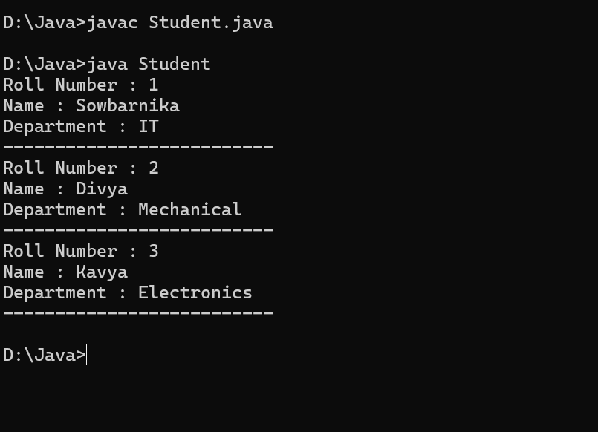

**Question 2:**

//Create a class called BankAccount with the following:

Account Number,Account Holder Name,Balance

Write methods to deposit, withdraw, and display balance. Create an object and perform all operations.

class BankAccount{

//Attributes

int accountNumber;

String accountHolderName;

double balance;

// Method to deposit money

void deposit(double amount){

balance += amount;

System.out.println("Deposited : Rs."+amount);

}

// Method to withdraw money

void withdrawn(double amount){

if(amount<=balance){

balance -= amount;

System.out.println("Withdrawn : Rs."+amount);

}else{

System.out.println("Insufficient balance!");

}

}

//Method to display balance

void displayBalance(){

System.out.println("Account Holder :" + accountHolderName);

System.out.println("Account Number :" + accountNumber);

System.out.println("Current Balance : Rs." + balance);

System.out.println("------------------------------------");

}

public static void main(String args[]){

//Create object

BankAccount account = new BankAccount();

account.accountNumber = 1234567;

account.accountHolderName = "Sowbarnika";

account.balance = 1000;

//Perform Operations

account.displayBalance();

account.deposit(500);

account.withdrawn(300);

account.displayBalance();

}

}

**OUTPUT :**

